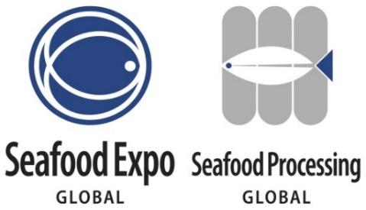

Exhibitor Press Release Template

- Feel free to use the following template to create a press release highlighting your company’s presence/products/news/special events at your booth related to the Expo that you want the media to know about.

- Once completed, please submit your press release as a Word doc to Lindsey Robinson, PR Specialist, at LRobinson@Divcom.com. The press release will be posted on the Expo’s website within 3-5 business days.

- To have your press release considered by the editorial team of Expo Today, the official media of the Expo, please submit it by Friday, 20 February 2026.

FOR IMMEDIATE RELEASE

[INSERT YOUR COMPANY LOGO]

[INSERT COMPANY NAME] [WHAT IS YOUR COMPANY DOING/SHOWCASING/LAUNCHING] at the World's Largest and Most Diverse Seafood Trade Event, Seafood Expo Global/Seafood Processing Global

[include any relevant details about what people can expect from your business at the expo]

[CITY, COUNTRY, DAY MONTH 2026 – COMPANY NAME (hyperlinked)] announces [WHAT IS YOUR COMPANY DOING/SHOWCASING/LAUNCHING] at the world's largest and most diverse seafood trade industry event, Seafood Expo Global/Seafood Processing Global. Organized by Diversified, the Expo will take place from 21 – 23 April 2026 at the FIRA Barcelona Gran Via Venue. [INCLUDE RELEVANT DETAILS ON YOUR COMPANY’S INVOLVEMENT AT THE EVENT - WHO/WHAT/WHERE CAN THEY FIND YOU/WHEN/WHY].

[QUOTE FROM COMPANY EXECUTIVE]

[EXPAND ON WHAT YOUR COMPANY IS DOING THAT’S DIFFERENT/UNIQUE/INTERESTING]

###

About [COMPANY NAME]:
[INSERT BOILER PLATE]

Media Contact:
[NAME, TITLE]
[COMPANY]
[EMAIL]
[WORK PHONE]

