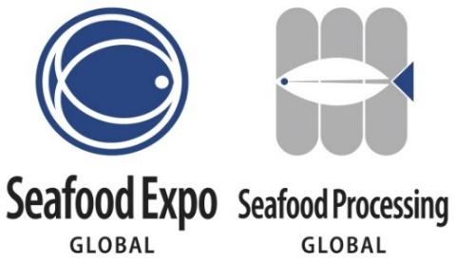

**Exhibitor Press Release Template**

* Feel free to use the following template to create a press release highlighting your company’s presence/products/news/special events at your booth related to the Expo that you want the media to know about.
* Once completed, please submit your press release as a Word doc to Lindsey Robinson, PR Specialist, at [LRobinson@Divcom.com](mailto:LRobinson@Divcom.com). The press release will be posted on the Expo’s website within three business days.

**FOR IMMEDIATE RELEASE**

**[INSERT YOUR COMPANY LOGO]**

**[INSERT COMPANY NAME] [WHAT IS YOUR COMPANY DOING/SHOWCASING/LAUNCHING] at the World's Largest and Most Diverse Seafood Event, Seafood Expo Global/Seafood Processing Global**

***[include any relevant details about what people can expect from your business at the expo]***

**[CITY, COUNTRY, DAY MONTH 2025 –** COMPANY NAME (hyperlinked)] announces [WHAT IS YOUR COMPANY DOING/SHOWCASING/LAUNCHING] at the world's largest and most diverse seafood industry event, [Seafood Expo Global/Seafood Processing Global](https://www.seafoodexpo.com/global/). Organized by Diversified, the Expo will take place from 6 – 8 May 2025 at the FIRA Barcelona Gran Via Venue. [INCLUDE RELEVANT DETAILS ON YOUR COMPANY’S INVOLVEMENT AT THE EVENT - WHO/WHAT/WHERE CAN THEY FIND YOU/WHEN/WHY].

[QUOTE FROM COMPANY EXECUTIVE]

[EXPAND ON WHAT YOUR COMPANY IS DOING THAT’S DIFFERENT/UNIQUE/INTERESTING]

###

**About [COMPANY NAME]:**

[INSERT BOILER PLATE]

**Media Contact:**

[NAME, TITLE]

[COMPANY]  
[EMAIL]

[WORK PHONE]