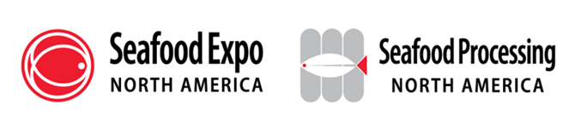

**Exhibitor Press Release Template**

* Feel free to use the following template to create a press release highlighting your company’s presence/products/news/special events at your booth related to the Expo that you want the media to know about.
* Once completed, please submit your press release as a Word doc to Lindsey Robinson, PR Specialist, at [LRobinson@Divcom.com](mailto:LRobinson@Divcom.com). The press release will be posted on the Expo’s website within three business days.
* To have your press release considered by the editorial team of *Expo Today*, the official publication of the Expo, please submit it by **Monday, January 15, 2025**.

**FOR IMMEDIATE RELEASE**

**[INSERT COMPANY LOGO]**

**[INSERT COMPANY NAME] [WHAT IS YOUR COMPANY DOING/SHOWCASING/LAUNCHING] at North America’s Largest Seafood Event, Seafood Expo North America/Seafood Processing North America**

***[include any relevant details about what people can expect from your business at the expo]***

**[CITY, STATE, MONTH XX,] 2025 –** [COMPANY NAME (hyperlinked)] announces [WHAT IS YOUR COMPANY DOING/SHOWCASING/LAUNCHING] at North America’s largest seafood event, [Seafood Expo North America/Seafood Processing North America](https://www.seafoodexpo.com/north-america/). Organized by Diversified, the Expo will take place from March 16 – 18, 2025 in Boston, MA at the Boston Convention and Exhibition Center. [INCLUDE RELEVANT DETAILS ON YOUR COMPANY’S INVOLVEMENT AT THE EVENT - WHO/WHAT/WHERE/WHEN/WHY].

[QUOTE FROM COMPANY EXECUTIVE]

[EXPAND ON WHAT YOUR COMPANY IS DOING THAT’S DIFFERENT/UNIQUE/INTERESTING]

###

**About [COMPANY NAME]:**

[INSERT BOILER PLATE]

**Media Contact:**

[NAME, TITLE]

[COMPANY]  
[EMAIL]

[WORK PHONE]